**HOTEL MANAGEMENT SYSTEM**



**SUBMITTED BY_:**

**CABINET KUMAR**

**11812420-K18PV**

**TABLE OF CONTENTS**

1. **INTRODUCTION**
2. **ABSTRACTION**
3. **ENTITY RELATIONSHIP DIAGRAMS**
4. **DATA FLOW DIAGRAMS**
5. **MODULES**
6. **LIBRARY USED**
7. **REFERENCE**

**INTRODUCTION**

My project title is “HOTEL MANAGEMENT SYSTEM”. I have tried my level best to make the complicated process of Hotel management system as simple as possible using python code, tkinter and filehandling etc. Moreover I have used DFD’s (data flow diagrams) and ER Daigram (Entity Relationship Daigram) to explain the process to use the Hotel management system. I have tried to design the project in such a way that customer may not have any difficulties in using the hotel management system. The main purpose of my project is to perform each employee’s activity in computerized way rather than manually which is time consuming.

This project can be used by two types of users and they are:

1. Customers
2. Administration (management of the hotel)

**ABSTRACTION**

In my project on “HOTEL MANAGEMENT SYSTEM”, I have tried my level best to show how the Data/Information in hotels is managed through the use of computer. This is just an overview of management in hotels. This has been achieved by dividing the projects into various modules. Customers is provided with different services like checking in, checking out, etc. If the customer want to enquiry about the hotel rooms whether it is occupied or vacant then they can check by using direct room numbers. Moreover, customer/administration of the hotel can have enquiry about the persons by their room nos. and also can see the complete list of people in the hotel. Administration of the hotel can compute bills and can forward to the customers. Customers can give their feedback.

As my purpose is to only have the idea or to study about how the management is done in hotels. It can be made better by adding some more modules.  
  
Hotel Management System has designed to computerize the following functions that are performed by the system.

1. Room detail function
2. Opening a new room
3. Checking in & checking out detail function
4. Admission of new customer
5. Checking out of customer
6. Checking in of costumer
7. Checking detail of employee
8. Room details
9. Total number of customer in the Hotel
10. Individual customer report
11. Enquiry of customer
12. Enquiry of rooms

**ENTITY RELATIONSHIP DIAGRAM**

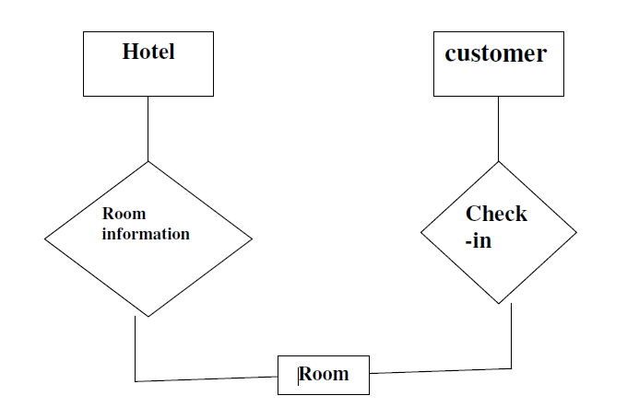

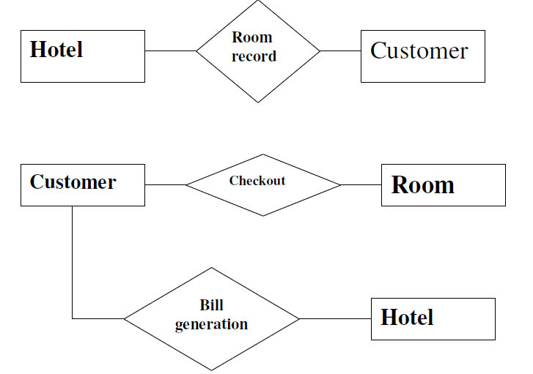

**DATAFLOW DIAGRAM FOR OPENING A NEW ROOM**

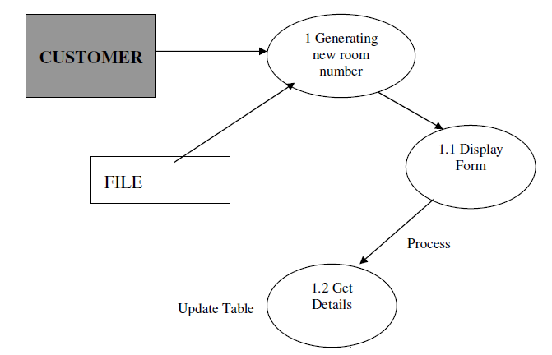

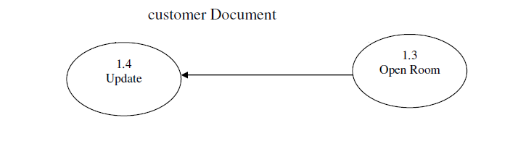

**DATAFLOW DIAGRAM FOR CHECKING IN A NEW CUSTOMER**

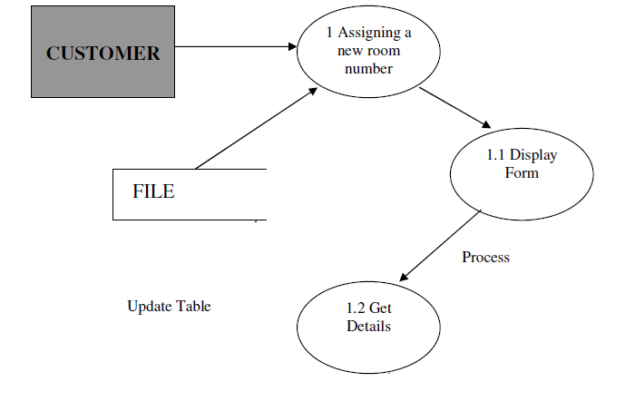

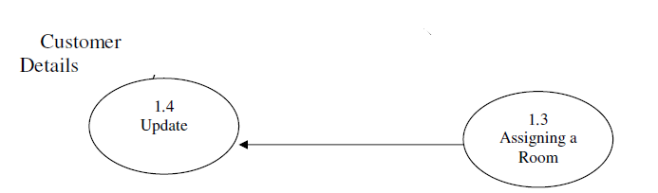

**DATAFLOW DIAGRAM FOR CHECKING OUT A CUSTOMER**

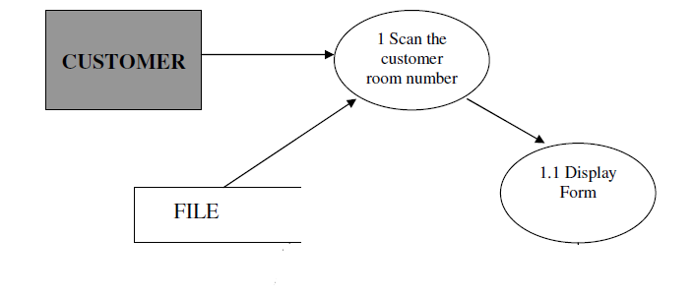

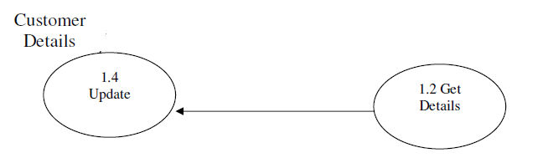

**DATAFLOW DIAGRAM FOR RECEIPT/BILLS FOR CUSTOMER**

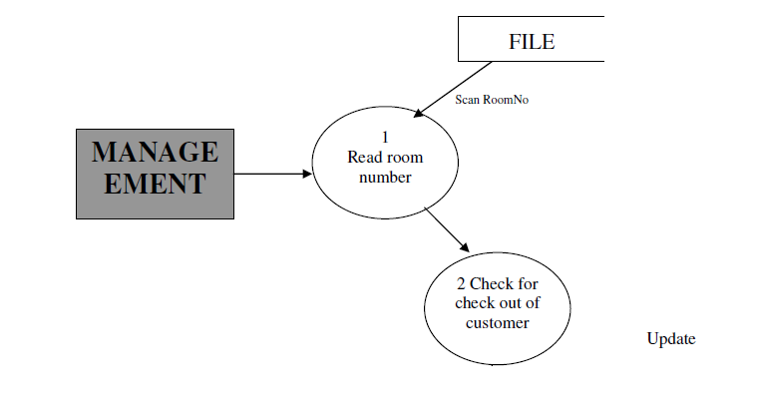

Customer

**MODULES**

1. **Login page**
2. **Signup/register page**
3. **Forgot password**
4. **Booking(check in & check out)**
5. **Monitoring the database**
6. **Bills/payment**
7. **Enquiry for rooms & customers**
8. **Enquiry for employee details**
9. **About us(Hotel facilities & many more)**
10. **Over-view**
11. **Location**
12. **Hotel Gallery**

**LIBRARY USED**

1. **Os**
2. **Sys**
3. **Subprocess**
4. **Call**
5. **Tkinter**
6. **SQLITE**
7. **Pickle**
8. **Time**
9. **Webbrowser**

**REFERENCES**

1. **Geek for geeks**
2. **Harry bro**
3. **Tutorial point**